**git clone**

* This will download all the code from the remote repository into the local repository.
* It is generally used only once when all the team members want a copy of the same code.
* Syntax:

git clone remote_git_repo_url

**git pull**

* Syntax:

git pull <remote-repo-url>

**Different ways of Authentication**

* It will ask for authentication.

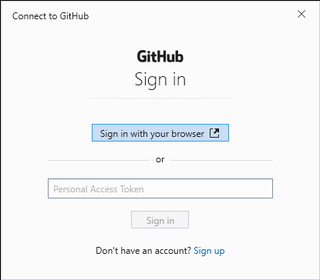

* Create Personal Access Token

My Profile 🡪 Settings -> Developer Setting 🡪 Personal Access Token (classic)

**Different ways to add file into staging area**

git add filename1

git add filename1 filename2

git add . [all files]

git add *.txt [all text file]

**Working with folders during commit**

mkdir demo

Ttuch demo/a.txt demo/b.txt

git add .

git commit –m “demo added”

git push

**git ignore**

* To ignore some files while committing

touch .gitignore ( creates a .gitignore file )

logs/ #completely ignore the folder & content inside

*.class #completely ignores files ending with .class

*.txt # completely ignores files ending with .txt

!test1.class # don’t ignore test1.class